# RMBL Phenology: The effects of a changing climate on migrating and over-wintering species at a high elevation field station

Adapted from: [The effects of a changing climate on migrating and over-wintering species at a high-elevation field station.](http://tiee.esa.org/vol/v13/issues/data_sets/wu/abstract.html)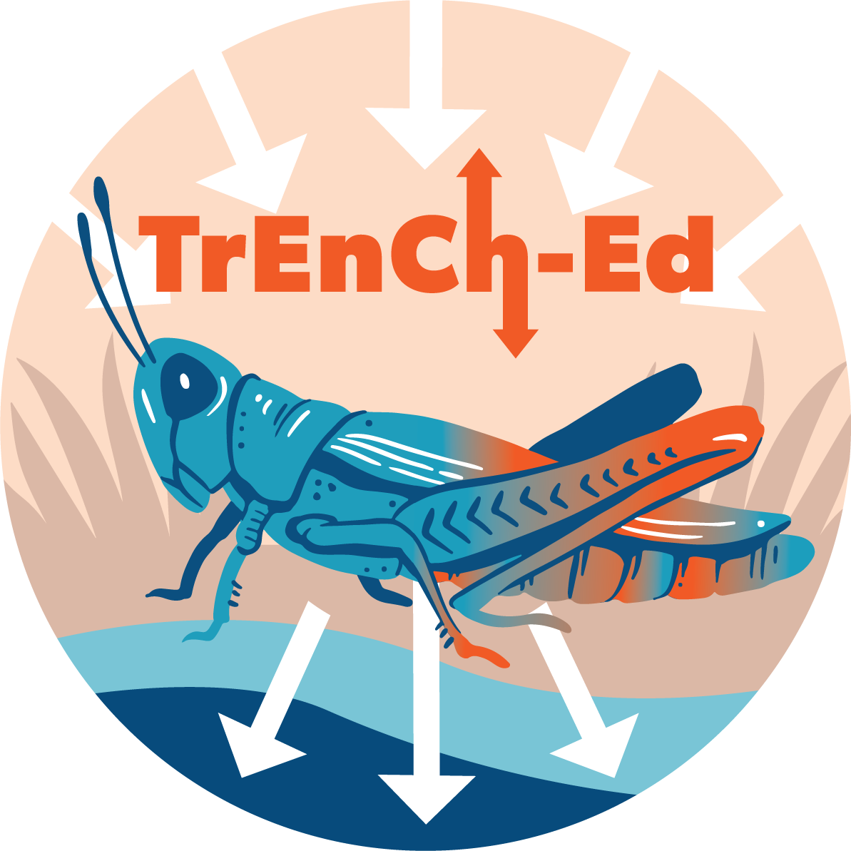

## [Link to the visualization](https://huckley.shinyapps.io/RShiny_RMBL-phenology/)

## [Link to TrEnCh-Ed](https://trench-ed.github.io/#)

Learn more about this research:

* [The Hermit Who Inadvertently Shaped Climate-Change Science](https://www.theatlantic.com/science/archive/2017/01/billy-barr-climate-change/512198/)
* [Climate change is affecting altitudinal migrants and hibernating species](https://www.ncbi.nlm.nih.gov/pmc/articles/PMC26486/)
* [The Snow Guardian](https://vimeo.com/182392548)
* [Time-lapse of snowpack at Snodgrass Mountain, CO.](https://www.youtube.com/watch?v=LCcbWK3UAUE&feature=youtu.be)

## Objectives

* How does climate change affect the phenology of species in a high-elevation ecosystem?
* How might these changes in temperature and snowmelt impact ecological interactions?
* The broader goals of this activity are to help you strengthen skills in: evaluating scientific figures, understanding statistical significance and regression, testing a hypothesis with a long-term dataset

## Cross-cutting concepts -- *Next Generation Science Standards*

* Cause and effect
* Scale, proportion, and quantity
* Stability and change

## Standards

Life Science Standards (LS)

|  |  |
| --- | --- |
| HS-LS2-6 | Evaluate claims, evidence, and reasoning that the complex interactions in ecosystems maintain relatively consistent numbers and types of organisms in stable conditions, but changing conditions may result in a new ecosystem. |

Advanced Placement Environmental Science

|  |  |
| --- | --- |
| 2.6 - Describe how organisms adapt to their environment. | * **ERT-2.H.1-** Organisms adapt to their environment over time, both in short- and long-term scales, via incremental changes at the genetic level. * **ERT-2.H.2** - Environmental changes, either sudden or gradual, may threaten a species’ survival, requiring individuals to alter behaviors, move, or perish. |

## Instructions

First, read through the RMBL Phenology introduction in the visualization. This will give you the required background information for these exercises. Then, answer these questions from the readings:

1. Numerous scientists have determined that the growing season is starting earlier at lower elevations. What did Inouye and colleagues determine was happening to the start of the growing season in the high Rockies around RMBL from the 1970s through the 1990s? Provide support for your response from Inouye et al. (2000).
2. How, if at all, do you think what Inouye observed might affect migrating species that visit the high Rockies in the summer? What about hibernating resident species?

### Part A. Change over time

For these questions, we will use the first “vs Year tab” and a time period of 1974 - 1999. All data come from RMBL. Look at the trendline analysis beneath the plot to determine the rate of change per year and the significance of the relationship.

1. Using the RMBL Phenology visualization, produce three plots (Figures 1, 3, and 4), from Inouye et al. (2000).

* Annual snowfall (cm)from 1974 to 1999
* Date of the first sighting of the American robin from 1974 to 1999 (*Hint: plot nothing for “snow condition” and only use “organism” to select the robin)*
* Date of the first sighting of the yellow-bellied marmot from 1974 to 1999

For each of the relationships depicted in those three figures, determine:

* What is the rate of change per year? (*Hint: look at the trendline analysis beneath the plot*)
* Is this rate of change (relationship found between the variables) significant? What supports your conclusion?

Do you see similar trends across all three relationships? If not, explain how they differ.

1. Have these trends held over the **longer term**? Choose either your earlier plot of the American robin or the yellow-bellied marmot to re-examine. Determine if the trends observed have held up in subsequent years by using two new time frames and generating plots with the new timeframes:

* An extended data set (1974-2010)
* The most recent decade (2000-2010)

1. Describe how the new plots you produced in question 4 **differ** from the plots you produced in question 3 (which were in Inouye et al. 2000). Do the original plots support the original interpretations? Justify your reasoning. Do the updated plots suggest new interpretations?
2. How have **abiotic** (non-living) conditions changed over the extended period of record? (*Hint: snow conditions)*
3. What are your predictions for future change?

### Part B: Phenotypic change due to abiotic changes

Go to the “vs snow conditions” tab for the next plot you’ll generate. This plots the date of the first lighting of an organism on the y-axis and the snow condition on the x-axis. Use the 1974-2010 extended time period and the snowmelt date as your snow condition. Choose any organism you want to plot its first sighting date, but ensure that the relationship plotted is significant.

1. For your organism, how much would its date of first sighting shift with a 5-day earlier snowmelt date? *(Hint: Use the slope of the regression line stated beneath the plot)*

### Part C: Generate and test a new hypothesis using the climate and phenology data

With your understanding of phenology and the visualization, here’s your chance to ask and answer your own questions. Feel free to use any organism and any snow conditions or (other weather conditions found in the “vs other weather conditions” tab).

1. Frame a question that you think you can answer using the data set that extends through 2010.
2. Generate one or more graphs to test your hypothesis.
3. Is the relationship significant? Is your hypothesis supported by the data?